Newsletter
Issue 2

15 September 2023

Dear Parents and Carers

It was lovely to see all the children (and staff!) arriving at school this morning dressed up to celebrate our 50th Anniversary. We had a wide range of eras 1970’s to the present day. The children also watched videos of children’s programmes and listened to music that were popular over the years.

We look forward to seeing as many of you as possible tomorrow at the Anniversary Festival – the weather is looking good and the PTA have lots of exciting things to see and do.

St Cross Annual Show
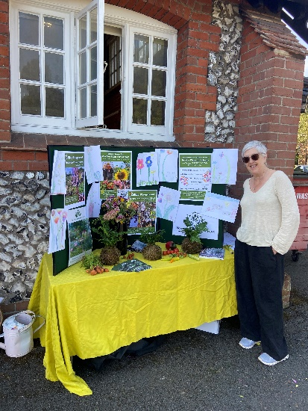
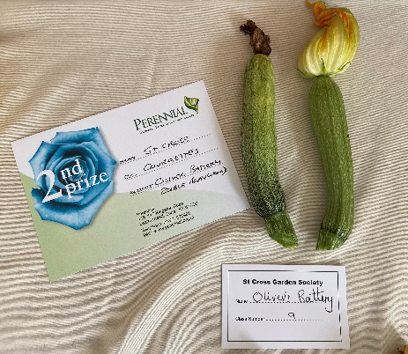
Hampshire Garden Society entered some of our produce from our edible garden and we were very successful with our courgettes which were placed 2nd! The children did some lovely drawings for the stand.

Parkrun
Please find attached a letter regarding Junior Parkrun.

School Council and House Captains
The following children have been selected by the children to represent the school.
School Council: Year 1 Amit and Lily
Year 2 Elle B and Alex
Year 3 Alma and Grace
Year 4 Torres, Pearl
Year 5 Lulu and Zac
Year 6 Paris

House Captains: Rowan (Red) Saar
Birch (Blue) Ava
Maple (Yellow) Harper
Oak (Green) Simar

Sports Ambassadors: Year 1 Leo and Frankie
Year 2 Crosby and Ema A
Year 3 Jack and Henry
Year 4 Lois and Jack
Year 5 Olivia and Oliver
Year 6 William and Grace

Secondary School Applications
Secondary School place applications for September 2024 are now open and will close on Tuesday 31 October 2023. Parents and Carers with children due to move to secondary school next year can now apply for their child’s school place. Applications can be submitted online or paper forms can be requested by emailing admissions.team@hants.gov.uk.

Request for Lego/Duplo
The lunchtime staff are starting a Quiet Club for children at lunchtimes and would be grateful for any donations of lego or duplo – thank you.

Rocksteady Club
Rocksteady who run classes at our school on Mondays currently have spaces and are looking for new members to join. Please pick up more information from the school office.

Child’s Anxiety Workshops
Hampshire CAMHS are running two online webinars for parents and carers of primary aged children offering information around what anxiety is and tips for how to support your child. Please find attached a flyer with some more information.

Hedgerow Foraging Walk
The Countryside charity are organizing a foraging walk exploring Compton Down on Saturday 23 September – please see the flyer on our noticeboard.
Learning Behaviours
We have held this week’s Learning Behaviours assembly. This is where each teacher chooses a child/children that has demonstrated the chosen learning behaviour of the week. The teacher shares with everyone what the child has done and then we all celebrate their achievement. This term we are looking at respect. The children who were chosen this week were:

Year One Leif
Year Two Evie Mc
Year Three Samuel P
Year Four Skye J
Year Five Lulu B
Year Six Ava

School Lunches
Thank you to everyone for settling their lunch accounts, however the lunch debts are now at an all-time high - please could you ensure that your account is kept up to date. For your information the money owed per class is as follows:-

Hares £ 200.33
Foxes £ 87.95
Herons £ 230.80
Kingfishers £ 333.80
Nursery £ 24.00

From Monday 18 September your child will not be able to order a school lunch if the debt is above £10.00 – if the debt is over £10.00 they will need to bring in a packed lunch. Please can you arrange to clear your Lunch accounts before next week.

If you would like an up to date statement of your child’s account please contact the Admin Team. If you have not yet registered to pay online via Scopay and would like a copy of your login details please email us and we will be happy to help. We would appreciate it if all accounts, including any outstanding Breakfast Club and After School Club accounts, could be settled as soon as possible. Please ensure that your After School Club Account is up to date as we employ extra staff for this club. If you would like an up to date statement please contact the school office.

Thank you for your continued support.

Yours faithfully

Mrs Bordoli
Interim Headteacher

Dates for your diary (new dates in red)
50th Anniversary Festival 11.30 – 3.30pm 16 September 2023
Open Morning 22 September 2023
Open Morning 19 October 2023
Inset Day 20 October 2023
Open Morning 29 November 2023
Open Morning 5 January 2023
Inset Day 19 February 2024
Inset Day 28 June 2024
Inset Day 1 July 2024

